Solution to The Video Lending Library Example
Part 1.
If we don’t want to keep track of past loan history, it is sufficient, for each copy, to keep track of:
- Which client has it, by keeping the client account number of who has loaned the copy in COPY (if the copy is in the library, we leave this field blank)
- When they borrowed it, by recording DateLoaned in COPY (if the copy is in the library, we leave this field blank).

MOVIE-----1<>M-----COPY------M<>1------CLIENT------M<>1-----ZIPCODE

MOVIE(MovieID, Title, ReleaseDate, Language, Category)

COPY(BarCode, Format, AcquireDate, UsedNew, DonatedPurchased, MovieID, ClientLoanedTo, DateLoaned)
MovieID foreign key to MOVIE
ClientLoanedTo foreign key to CLIENT

CLIENT(AcctNumber, FirstName, LastName, Address, Zip, Phone)
Zip foreign key to ZIPCODE

ZIPCODE(Zip, City, State)

Part 2.
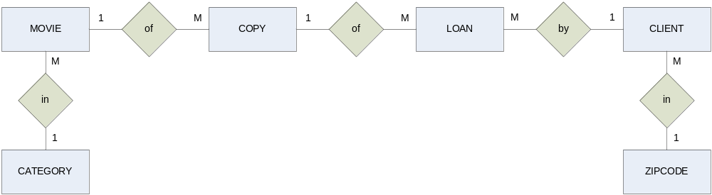

MOVIE(MovieID, Title, ReleaseDate, Language, Category)

COPY(BarCode, Format, AcquireDate, MovieID)
MovieID foreign key to MOVIE

LOAN(LoanID, AcctNumber, BarCode, DateLoaned, DateReturned)
AcctNumber foreign key to CLIENT
BarCode foreign key to COPY

CLIENT(AcctNumber, FirstName, LastName, Address, Zip, Phone)
Zip foreign key to ZIPCODE
ZIPCODE(Zip, City, State)

